**DAILY ONLINE ACTIVITIES SUMMARY**

|  |  |  |  |  |  |  |
| --- | --- | --- | --- | --- | --- | --- |
| **Date:** | | **01/06/2020** | | | | |
| **Name of the Faculty** | | **Shilpa** | | | | |
| **No. of Students Allotted for monitoring** | | | | **19** | | |
| **Progress** | | | | **Good** | | |
| **Whether collected report from all the allotted students** | | | | **15 submitted.** | | |
| **Online Test Summary** | | | | | | |
| **Subject** |  | | | | | |
| **Semester** |  | | | **Duration** |  | |
| **No. of students Taken** | | |  | **Passing %** |  | |
| **Certification Course Summary** | | | | | | |
| **Course** | | **1. Webinar on Understanding Social Media through Analytics**  **2. Webinar on Personality Development through Online Courses , The 3 Dimensional Learning**  **3. Mastering Machine Learning** | | | | |
| **Certificate Provider** | | 1. Sri Ramakrishna Institute of Technology, 2. Vivekananda Institute of Technology 3. Pantech e-learning. | | **Duration** | | **1 Hour each** |
| **Coding Challenges** | | | | | | |
| **Problem Statement: -** | | | | | | |
| **Status: -** | | | | | | |
| **Uploaded the report in Github** | | | |  | | |
| **If yes Repository name** | | | |  | | |
| **Uploaded the report in slack** | | | |  | | |

**Certification/webinar Course Summary**



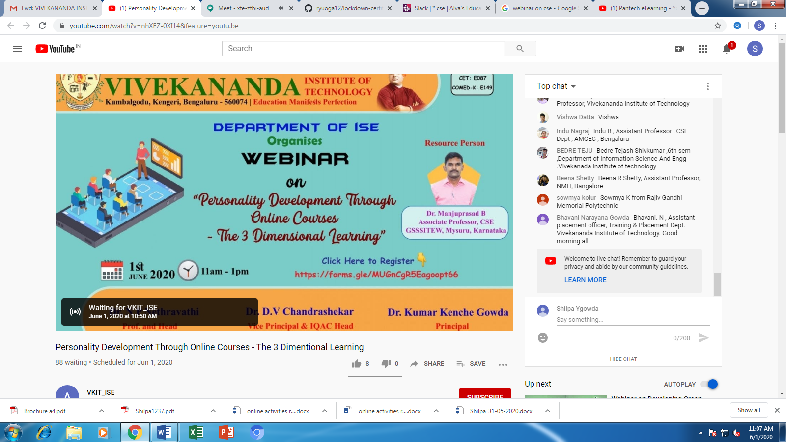

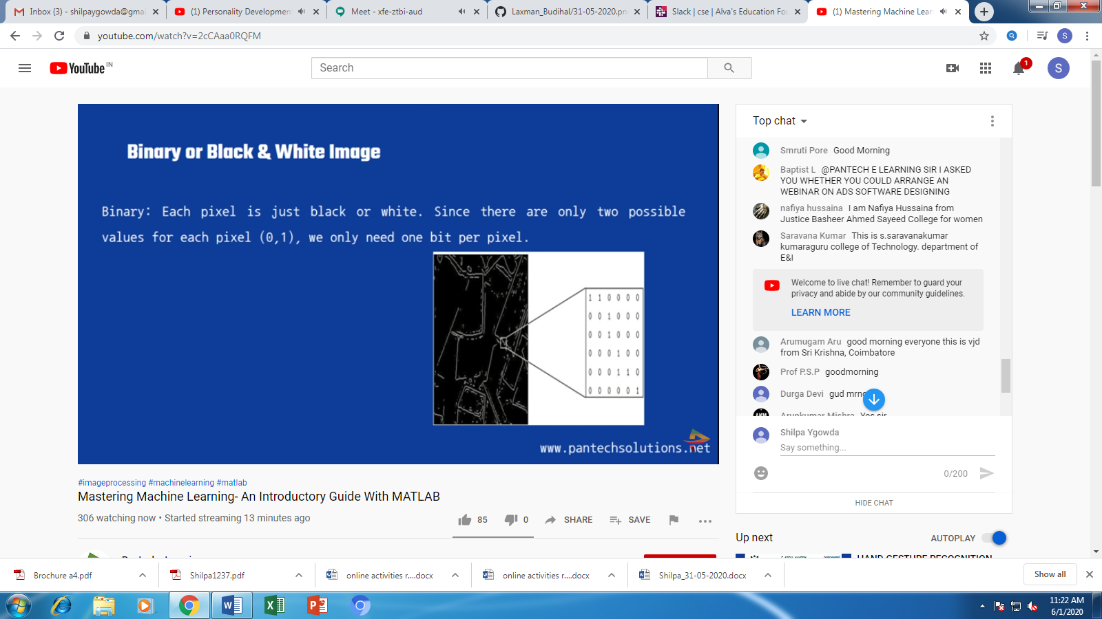

**Students Report:**

